**Appendix: A**

# **Enrolment_Growth_Rate by Year:**

# 

# **Demographics by School:**

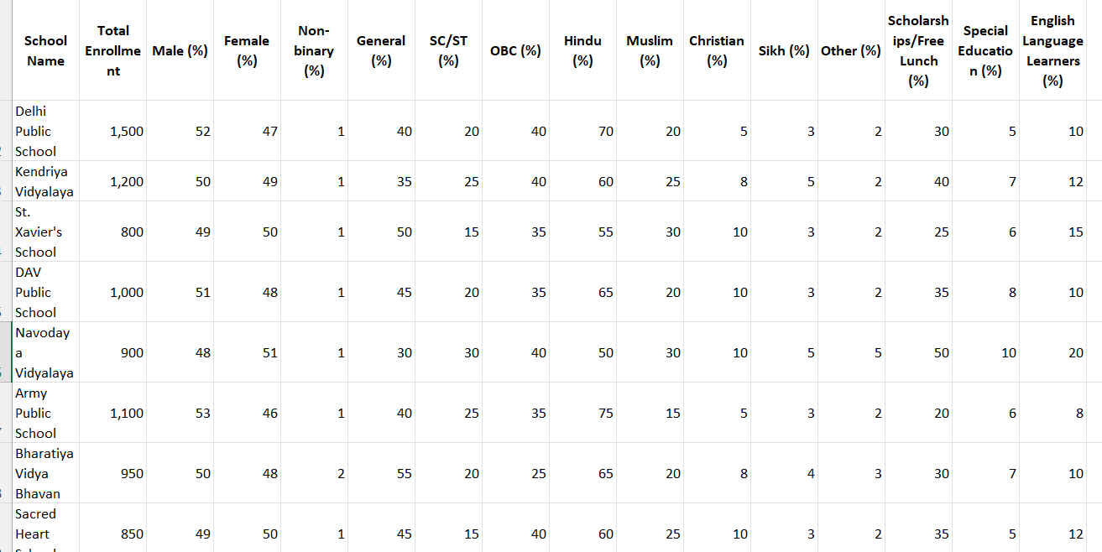

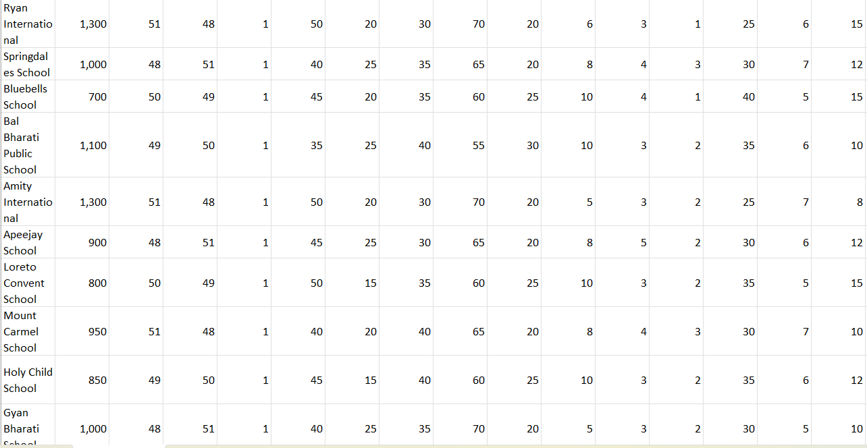

# **Teacher’s Attrition by Year:**

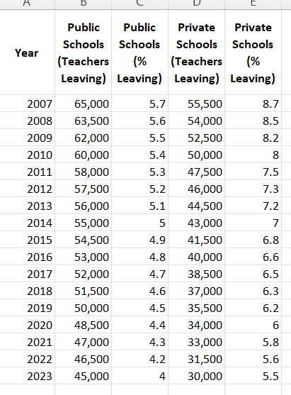

# **Feedback:**

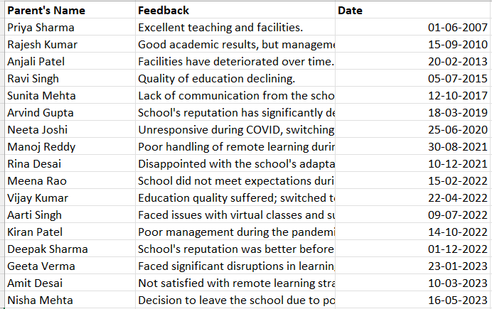

# **Academics and Extracurricular performances by Year:**

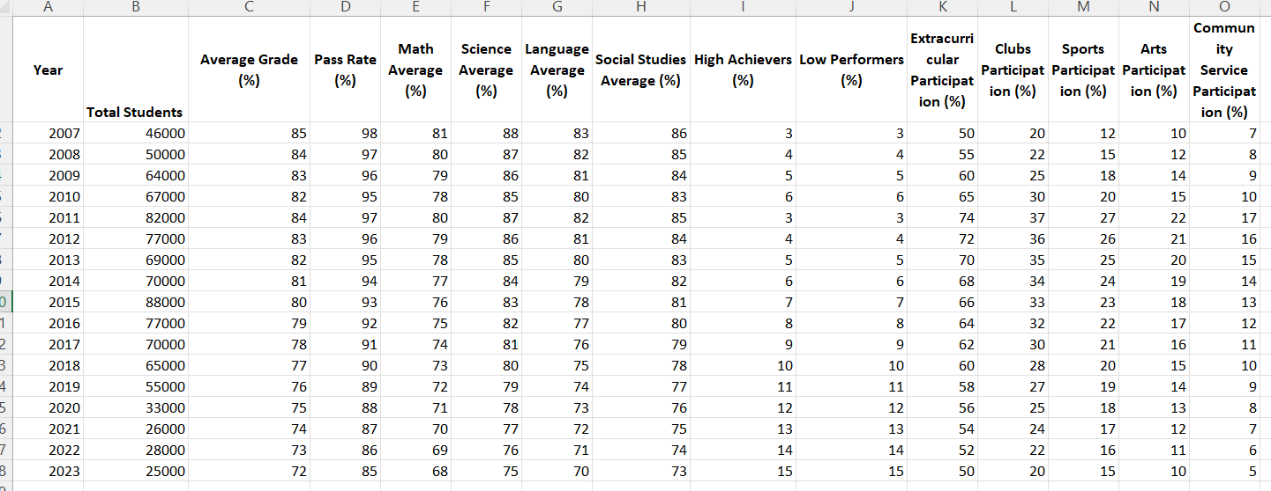

# **No. of Enrolments recorded by Year:**

